
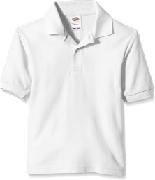
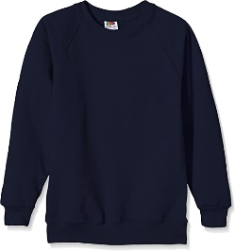

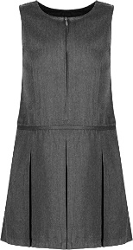
School Uniform
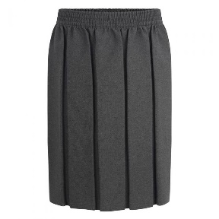
Girls – Grey skirt/dress or trousers, white polo shirt and blue school jumper/black shoes.
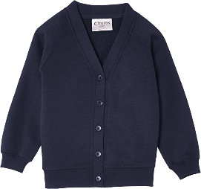
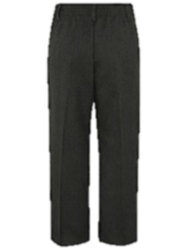
Boys – Grey trousers, white polo shirt and blue school jumper/black shoes.
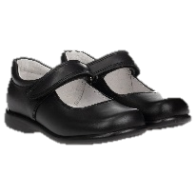
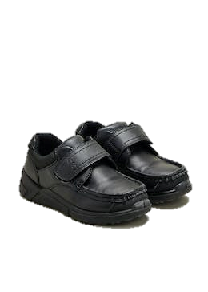

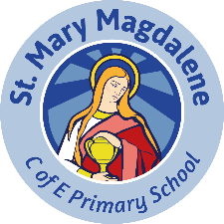
School Badge

School badges are iron on and for sale on ParentPay through school. Once your child has been admitted to school you will receive a ParentPay activation letter.

PE Kit
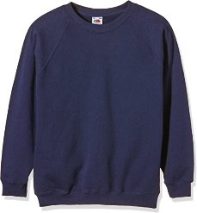
On PE days children attend school in PE kit.
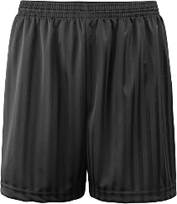
PE kits need to include:
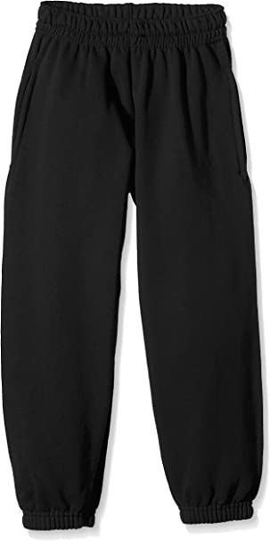
- Pumps
- Black shorts
- Black jogging bottoms
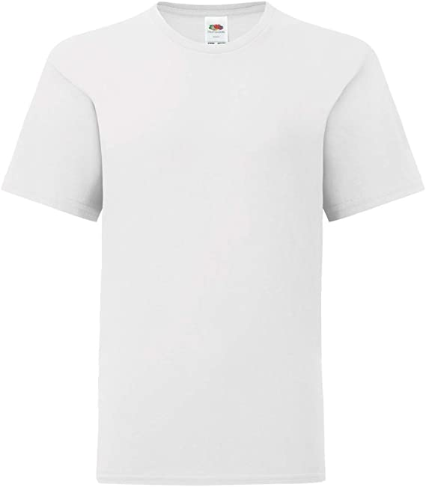
- White t-shirt
- Outside jumper
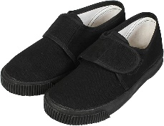

PLEASE ENSURE ALL CLOTHES ARE LABELLED WITH YOUR CHILD’S NAME

